|  |  |  |  |
| --- | --- | --- | --- |
| **Name:** | Harold Raynel Y. David | **Date:** | September 15, 2023 |
| **Program:** | CPE | **Section:** | A361 |

**Intended Learning Outcomes:**

# Create output with JavaScript.

1. Utilize JavaScript variables and data types.

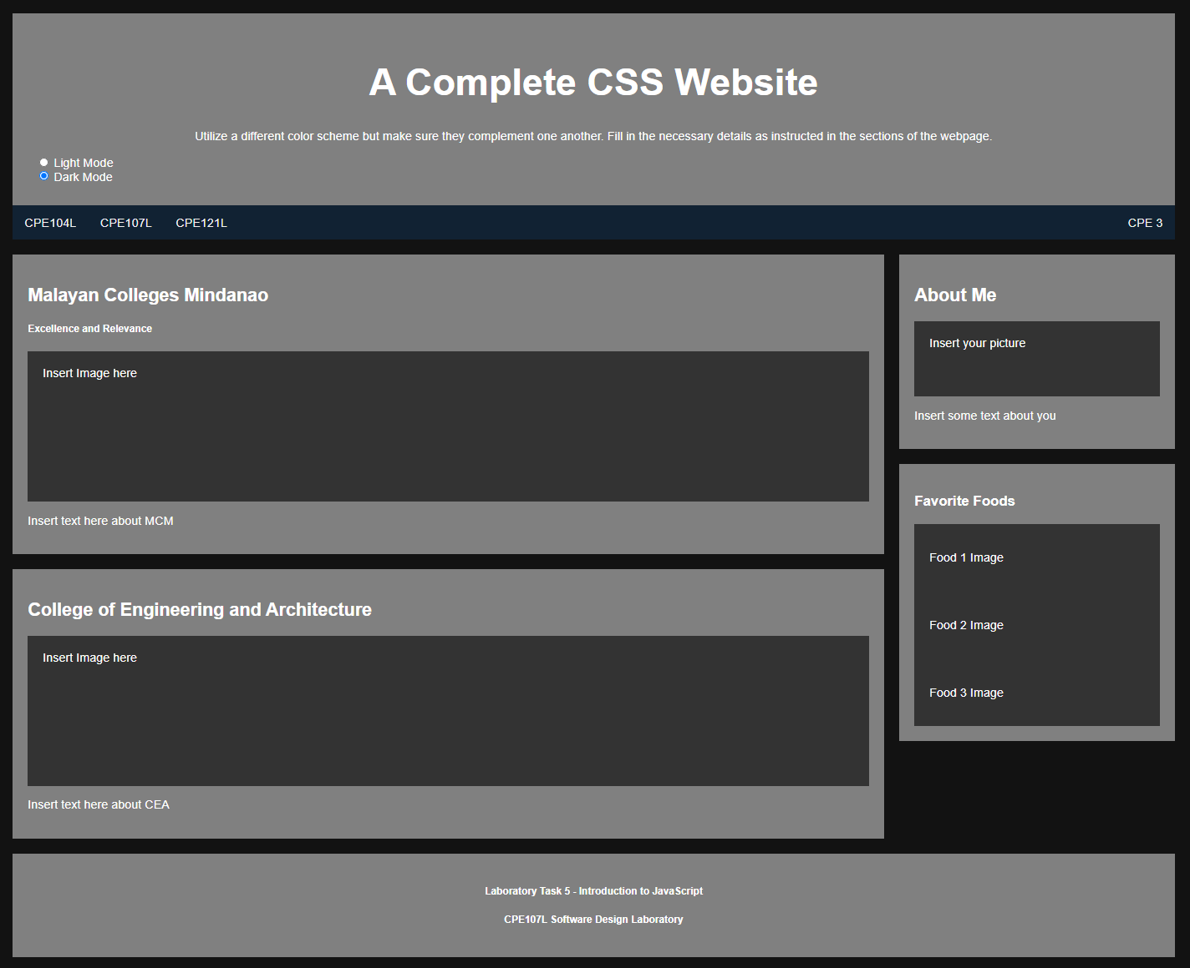

Using your output from Laboratory Task 4, include a button/check box/radio button/toggle switch that will change your website into **DARK MODE**. Here is an example output:

**CPE143L Web Design and Development**

================================================================================

**HTML Source Code:**

<!DOCTYPE html>

<html>

<div class = "head">

<head>

<link rel="stylesheet" href="C:\Users\LENOVO\OneDrive\Documents\GitHub\har_old.github.io\Laboratory_Task_4-David\lab4Style.css">

<title>LabTask4</title>

<header>A Complete CSS Website</header><br>

<p class ="p1">Utilize a different color scheme but make sure they complement one another. Fill in the necessary details as instructed in the sections of the webpage.</p>

<button id="darkModeToggle">Toggle Dark Mode</button></br>

<ul class="course">

<li><a>CPE143L</a></li>

<li><a>CPE107L</a></li>

</ul>

</head>

</div>

<body>

<script src = "task5.js"></script>

<div class="left">

<div class="mcm">

<h2>

Malayan Colleges Mindanao

</h2>

<p>Excellence and Relevance</p>

<image src="C:\Users\LENOVO\Downloads\mcm2.jpg" width="700px" height="300px" class="img1"></image><!--Put Image Here-->

<p>MMCM or Mapua Malayan Colleges Mindanao is a branch of Mapua University which began operations on July 2, 2018, and on July 7, 2018, it held its formal opening ceremony.</p>

</div>

<div class="cea">

<h2>

College of Engineering and Architecture

</h2>

<image src="C:\Users\LENOVO\Downloads\cea.jpg" width="300px" height="300px" class="img2"></image><!--Put Image Here-->

<p>Graduates of the College of Engineering and Architecture (CEA) are transformed into leaders who are inventive, globally competitive, socially responsible, and goal-oriented engineers and architects.</p>

</div>

</div>

<div class="right">

<div class="about">

<h2 class="about">

About Me

</h2>

<!--Put Image Here-->

<p>I was born in Cotabato City and was raised in Davao City. I'm 21 years old and currently studying in Mapua Malayan Colleges Mindanao.</p>

</div>

<div class="food">

<h2 class="food">Favorite Foods</h2>

<image src="C:\Users\LENOVO\Downloads\Pizza1.jpg" width="150px" height="150px" class="pizza"></image><br>

<image src="C:\Users\LENOVO\Downloads\Fried.jpg" width="150px" height="150px" class="chicken"></image><!--Put 3 Image Here-->

</div>

</div>

<div class="footer">

<section><br>

<p class="lab">Laboratory Task 4 - Advanced CSS Styling</p>

<p class="cpe">CPE143L Web Design and Development</p><br>

</section>

</div>

</body>

</html>

**CSS Source Code:**

html{

margin-top: 15px;

margin-bottom: 15px;

margin-left: 15px;

margin-right: 15px;

}

ul{

list-style-type: none;

margin: 0;

padding: 0;

overflow: hidden;

color: white;

}

li{

float: left;

}

li a{

display: block;

padding: 8px;

}

p.p1{

text-align: center;

}

header{

font-size: 40px;

text-align: center;

}

ul.course{

background-color: red;

margin-left: 15px;

margin-right: 15px;

}

div.footer{

background-color: red;

text-align: center;

margin-left: 15px;

margin-right: 15px;

color: white;

}

div.mcm{

border: solid 1px;

margin: 1rem;

padding: 15px;

}

div.cea{

border: solid 1px;

margin: 1rem;

padding: 15px;

}

div.about{

border: solid 1px;

margin: 1rem;

padding: 10px;

text-align: justify;

text-justify: inter-word;

word-wrap: break-word;

}

div.food{

border: solid 1px;

margin: 1rem;

padding: 10px;

word-wrap: break-word;

}

div.left{

float: left;

width: 80%;

}

div.right{

float: right;

width:20%;

}

h2.about{

text-align: center;

}

h2.food{

text-align: center;

}

div.footer{

clear: both;

}

.img1{

display:block;

margin-left: auto;

margin-right: auto;

}

.img2{

display:block;

margin-left: auto;

margin-right: auto;

}

.pizza{

display:block;

margin-left: auto;

margin-right: auto;

object-fit: cover;

}

.chicken{

display:block;

margin-left: auto;

margin-right: auto;

object-fit: cover;

}

div.head{

border: solid 1px;

margin: 1rem;

padding: 15px;

}

.dark-mode{

background-color: black;

color: white;

}

button{

margin: 1rem;

}

**JavaScript Source Code:**

document.getElementById('darkModeToggle').addEventListener('click', function() {

document.body.classList.toggle('dark-mode');

});

**Output:**

**Findings and Observations:**

Learning and intergrating javaScript in the html or website is a bit challenging at first. However, the more I learn more about javascripting, the more I understand how to intergrate it to the html.